Dominance of Intensity Inverters in Sustainable and Brilliant Matrix Coordination

Madhuri Sinha¹, Vijay Saxena²

Electrical and Electronics Engineering, Vishnu Institute of Technology-Bhimavaram, India^{1,2.}

Abstract— The world gives growing thought to effective force essentialness, imperativeness conservation and doable headway as the heaviness of overall resources creating. Practical force source, with its low pollution and sensible accessibility, will replace the traditional fossil imperativeness. This article presents the improvement of economical force source, the splendid lattice, and the essential development used in the clever system controlling the essentialness.
Keywords— Smart Matrix, Sustainable power source Fossil Vitality, Force Controlling.

1. Introduction
The usage of reasonable force source extended fundamentally not long after the principle enormous oil crisis in the late seventies. Around at that point, fiscal issues were the hugest parts, from now on the eagerness for such methods lessened when oil costs fell. The present resurgence of eagerness for the use of economical force source is driven by the need to diminish the high natural impact of fossil-based imperativeness structures. Procuring essentialness on a gigantic scale is the point of fact one of the central challenges inside ongoing memory. Future energy sustainability depends heavily on how the renewable energy problem is addressed in the next few decades. Although in most power-generating systems, the main source of energy (the fuel) can be manipulated, this is not true for solar and wind energies. The main problems with these energy sources are cost and availability: wind and solar power are not always available where and when needed. Unlike conventional sources of electric power, these renewable sources are not “dispatchable”—the power output cannot be controlled. Daily and seasonal effects and limited predictability result in intermittent generation. Smart grids promise to facilitate the integration of renewable energy and will provide other benefits well.
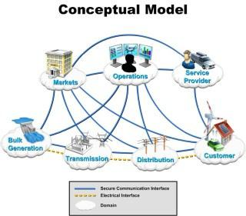

Industry must overcome a number of technical issues to deliver renewable energy in significant quantities. Control is one of the keys enabling technologies for the deployment of renewable energy systems. Solar and wind power require effective use of advanced control techniques. In addition, smart grids cannot be achieved without extensive use of control technologies at all levels.
2. Successful Applications of control wind energy
Charles F. Brush is widely credited with designing and erecting the world’s first automatically operating wind turbine for electricity generation. The turbine, which was installed in Cleveland, Ohio, in 1887, operated for 20 years with a peak power production of 12 kW (Fig. 2). An automatic control system ensured that the turbine achieved effective action at 6.6 rpm (330 rpm at the dynamo) and that the dc voltage was kept between 70 and 90 volts. Another remarkable project in early wind energy research was the 1.25-MW wind turbine developed by Palmer Putnam [3] in the U.S. The giant wind turbine, which was 53 m (175 feet) in diameter, was installed in Vermont, Pennsylvania, around 1940 and featured two blades with a hydraulic pitch control system. Modern wind-driven electricity generators began appearing during the late 1970s. At that time, the average power output of a wind turbine unit was about 50 kW with a blade length of 8 m. Since.

Nowadays, there are essentially two types of wind turbines: constant-speed and variable-speed machines. Until the late nineties, the constant-speed concept dominated the market. Today, it still represents a significant share of the operating wind turbines, but newer requirements have led to the emergence of variable-speed designs [5],[9],[10],[11].
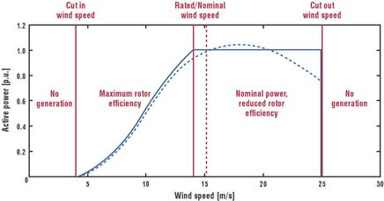

Three fundamental elective techniques are utilized for controlling the measure of intensity caught by the rotor:

Latent slow down control or fixed pitch, variable pitch control, and dynamic slow down control. Up until now, over the whole scope of wind turbine measures, nobody of these systems has led the pack over the others. Be that as it may, as machines get bigger and power creation expands, the pattern is toward pitch control and dynamic slowdown control [5],[9],[10],[11].The arrangement of a fixed-speed wind turbine depends on a gearbox and an offbeat generator, which is normally a squirrel-confine enlistment generator to diminish costs. The gearbox interfaces the breeze turbine shaft with the rotor of a fixed-speed generator, giving the high rotational speed required by the generator.
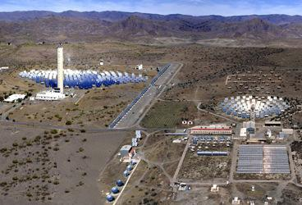

3. Solar Vitality
A handful of thermal solar vitality plants, most of them experimental, have been developed over the last two decades. The Solar One power tower [13], developed in Southern California in 1981, was in operation from 1982 to 1986. It used 1,818 mirrors, each 40 m², for a total area of 72,650 m². The plant was transformed into Solar Two by adding a second ring of larger (95 m²) heliostats and molten salts as a storage medium. This gave Solar Two the ability to produce 10 MW and helped with energy storage, not only during brief interruptions in sunlight due to clouds, but also to store sufficient energy for use at night. Solar Two was decommissioned in 1999 but proved it could produce power continuously around the clock.

The Solar Tower Power Plant SSPS was developed in 1980 in the Platform a Solar de Almeria (PSA) on the edge of the Tabernas Desert in Spain (Fig. 5). The plant had 92 heliostats (40 m²) producing 2.7 MWth at the focal point of the 43-m-high tower where the heat was collected by liquid sodium. The PSA has a number of experimental plants such as the CESA-1 7-MWth central receiver system and the SSPS-OCS 1.2-MWth parabolicity rough collector system with associated thermal storage.
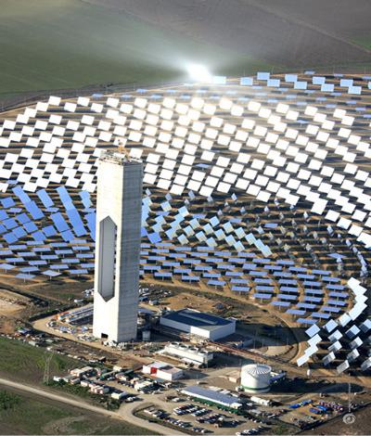

To avoid deterioration due to excessive thermal gradients in central volumetric receivers, multi-aiming strategies are used [17] to obtain an appropriate flux distribution. Individual heliostats are intentionally focused on various pointing focuses so that progressively uniform irradiance is gotten in the focal recipient.

4. Smart Matrices
Smart grid concepts encompass a wide range of technologies and applications. We describe a few below that are currently in practice with the caveat that, at this early stage in the development of smart grids, the role of control, especially advanced control, is limited:

- Advanced metering infrastructure (AMI) is a vision for two-way meter/utility communication. Two fundamental elements of AMI have been implemented. First, automatic meter reading (AMR) systems provide an initial step toward lowering the costs of data gathering through use of real-time metering information. They also facilitate remote disconnection/reconnection of consumers, load control, detection of and response to outages, energy theft responsiveness, and monitoring of power quality and consumption. Second, meter data management (MDM) provides a single point of integration for the full range of meter data. It enables leveraging of that data to automate business processes in real time and sharing of the data with key business and operational applications to improve efficiency and support decision making across the enterprise.

- Distribution management system (DMS) software mathematically models the electric distribution network and predicts the impact of outages, transmission, generation, voltage/frequency variation, and more. It helps reduce capital investment by showing how to better utilize existing assets, by enabling peak shaving via demand response (DR), and by improving network reliability. It also facilitates consumer choice by helping identify rate options best suited to each consumer and supports the business case for renewable generation solutions (distributed generation) and for electric vehicles and charging station management.

- Geographic information system (GIS) technology is specifically designed for the utility industry to model, design, and manage their critical infrastructure. By integrating utility data and

- geographical maps, GIS provides a graphical view of the infrastructure that supports cost reduction through simplified planning and analysis and reduced operational response times.

- Outage management systems (OMSs) speed outage resolution so power is restored more rapidly and outage costs are contained. They eliminate the cost of manual reporting, analyze historical outage data to identify improvements and avoid future outages, and address regulatory and consumer demand for better responsiveness.

- Intelligent electronics devices (IEDs) are advanced, application-enabled devices installed in the field that process, compute, and transmit pertinent information to a higher level. IEDs can collect data from both the network and consumers’ facilities (behind the meter) and allow network reconfiguration either locally or on command from the control center.

- Wide-area measurement systems (WAMS) provide accurate, synchronized measurements from across large-scale power grids. They have been implemented in numerous power systems around the world, following initial developments within the Western Electricity Coordinating Council (WECC) through the early 1990s [19]. WAMS consist of phasor measurement units (PMUs) that provide precise, time-stamped data, together with phasor data concentrators that aggregate the data and perform event recording. WAMS data plays a vital role in post disturbance analysis, validation of system dynamic models, FACTS control verification, and wide area protection schemes. Future implementation of wide-area control schemes is expected to build on WAMS.

- Energy management systems (EMSs) at customer premises can control consumption, onsite generation and storage, and potentially electric vehicle charging. EMSs are in use today in large industrial and commercial facilities and will likely be broadly adopted with the rollout of smart grids. Facility energy management can be seen as a large-scale optimization problem: Given current and (possibly uncertain) future information on pricing, consumption preferences, distributed generation prospects, and other factors, how should devices and systems be used optimally?

Smart grid implementations are occurring rapidly, with numerous projects under way around the world. Fortum’s “intelligent management system of electric consumption” uses advanced metering devices to gather customer’s consumption data and metering management systems to store and analyze this information. Vattenfall’s “automatic household electricity consumption metering system” is another example of a European project that is focused on remote measurement of consumers. Also, projects such as Elektra’s “distribution management system” improve quality of service by implementing nextgeneration devices to manage and control information (SCADA), DMS to plan and optimize distribution system operations, and ArcFM/Responder to improve outage response times.
5. Market Sizes and Investment [15], [20], [21]

5.1 Wind Energy
With many thousands of wind turbines in operation, the total worldwide installed capacity is currently about 160 GW. According to the World Wind Energy Association, the net growth rate is expected to be more than 21% per year. The top five countries, the United States, Germany, Spain, China, and India, currently share about 73% of the world capacity. The cost of electricity from utility-scale wind farms has dropped by more than 80% over the last 20 years, reaching values of about $2.2 and $4.6 million per megawatt for onshore and offshore applications, respectively, in 2010. According to the U.S. Department of Energy, the capital cost of onshore applications can be further reduced to about 10% of current cost over the next two decades. In addition, several countries have adopted special programs to subsidize and promote wind energy.

Among the most successful ones are the feed-in-tariff (FiT) programs and the production tax credit (PTC) programs. The FiT programs have been adopted by more than 60 countries and states all over the world, including some of the top-producing countries: Germany, Spain, Canada, and Denmark. They typically include:
- guaranteed grid access for the wind farm,
- long-term contracts to sell the electricity produced by the wind turbines, and
- purchase prices for distributed renewable generation that are substantially higher than the retail price of electricity (and will gradually be reduced toward grid parity).

5.2 Solar Energy
Solar photovoltaic generation installed capacity has grown about 40% since 2002. Thermal power plants are growing rapidly, with more than 2 GW under construction and some 14 GW announced through 2014. Spain is the epicenter of solar thermal power development with 22 projects under development for 1,081 MW capacity [24]. In the United States, 5,600 MW of solar thermal power projects have been announced. Currently (as of July, 2010), 679 MW of CSP capacity are installed worldwide. The U.S. is the market leader in terms of installed capacity with 63% market share, followed by Spain with 32%. These two markets will continue to be crucial for the development of the industry into the next decade, with Spain accounting for the largest share of projects under construction with almost 89%. Solar generation is taking off in emerging regions as well; both China and India have announced plans for large-scale solar plants. On July 3, 2010, U.S. President Obama announced that “the Department of Energy is awarding nearly $2 billion in conditional commitments to two solar companies. The first is Abengoa Solar, a company that has agreed to build one of the largest solar plants in the world right here in the United States. Once completed, this plant will be the first large-scale solar plant in the U.S and it will generate enough clean, renewable energy to power 70,000 homes. The second company is Abound Solar Manufacturing, which will manufacture advanced solar panels at two new plants. When fully operational, these plants will produce millions of state-of-the-art solar panels each year” *25].

6. Application Challenges/Opportunities for Research [5], [20], [29]

6.1 Wind Energy
The enormous and unique worldwide possibilities for large-scale wind energy development over the next few decades depend greatly on how critical technology challenges are addressed. New ideas and control engineering solutions are needed to open virgin global markets. Among others, we emphasize the seven technology challenges (TCs) listed in below. Wind Energy Challenges

TC.1 Cost reduction for a zero-incentive situation
TC.2 Efficiency maximization
TC.3 Mechanical load attenuation
TC.4 Large-scale grid integration and penetration
TC.5 Extreme weather conditions
TC.6 Offshore wind turbines
TC.7 Airborne wind energy systems

6.2 Solar Energy
One of the 21st Century's Grand Challenges for Engineering identified by the U.S. National Academy of Engineering is to make solar energy economical: “Overcoming the barriers to widespread solar power generation will require engineering innovations in several arenas—for capturing the sun’s energy, converting it to useful forms and storing it for use when the sun itself is obscured” *34].

6.3 Smart Grids
A significant challenge associated with smart grids is the integration of renewable generation. Traditionally, power systems have addressed the uncertainty of load demand by controlling supply. With renewable energy sources, however, uncertainty and intermittency on the supply side must also be managed. Demand response and load control—direct and indirect mechanisms to adjust consumption—are required.

7. Conclusion
Most national vitality arrangements overall target guaranteeing a vitality portfolio that supports a cleaner situation and more grounded economy and that fortifying the national security by giving a steady, different, household vitality supply. Clean vitality is a worldwide and pressing objective. Sustainable age, particularly from wind and sun powered, and shrewd lattice ideas are basic advances expected to address a dangerous atmospheric deviation and related issues. The key test is to lessen the expense of sustainable power sources to moderate levels. Control and related innovations will be basic for taking care of these perplexing issues.

8. References
[1] U.S. Department of Energy. Office of Electricity Delivery and Energy Reliability, Recovery Act Financial Assistance Funding Opportunity Announcement, Smart Grid Investment Grant Program, DE-FOA-0000058, June 25, 2009.

[2] P.C. Putnam. Power from the Wind. New York: Van Nostrand Reinhold, 1948.

[3] Garrad Hassan. GH Bladed software, 2010.

[4] M. Garcia-Sanz and C.H. Houpis. Wind Energy Systems: Control Engineering Design. Boca Raton, FL: Taylor & Francis, 2011.

[5] Germanischer Lloyd. Wind turbine standards and certification, 2010.

[6] Dr. Damanjeet Kaur, “Smart Grids and India” International Journal of Electrical Engineering & Technology (IJEET), Volume 1, Issue 1, 2010, pp. 157 - 164, ISSN Print: 0976-6545, ISSN Online: 0976-6553 Published by IAEME

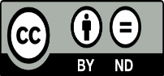
This work is licensed under a Creative Commons Attribution Non-Commercial 4.0 International License.

